Assignment 2- Part 1 - Report
Natalie Poche

Part 1: Bandit_2
Level 6:
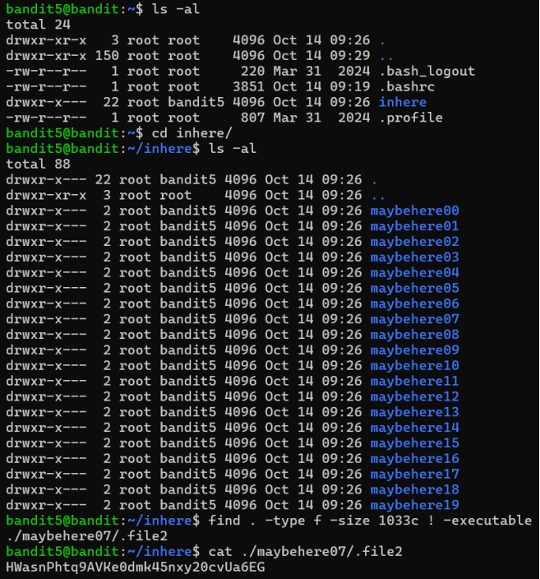
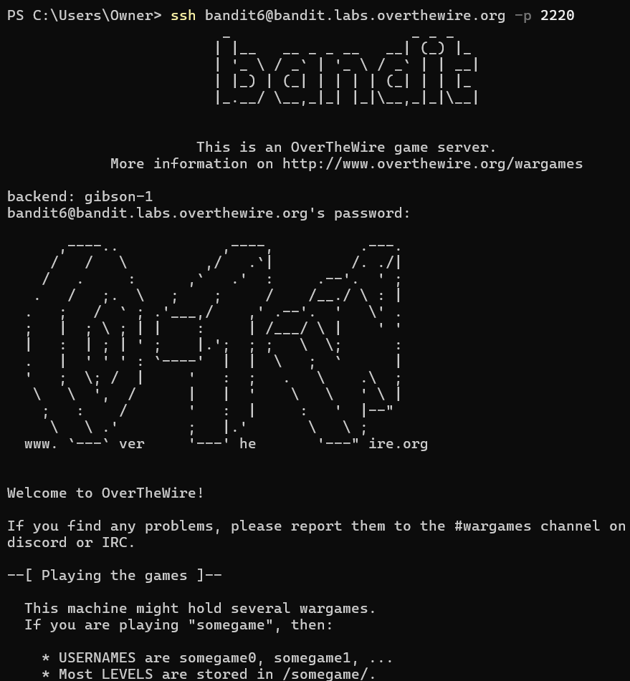
Used find . -type f -size 1033c ! -executable, where find is used to search the current directories and subfolder based on the ., the flag -type is used to specify we are looking for a file not a directory, -size 1033c is used to narrow down the search to a file that is 1033 bytes in size, and ! -executable specified that we are looking for files without executable permissions. Then cat is used to print out the file that matches the criteria.

Level 7:
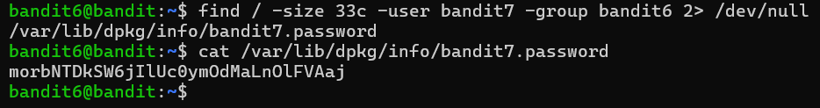
morbNTDkSW6jIlUc0ymOdMaLnOlFVAaj
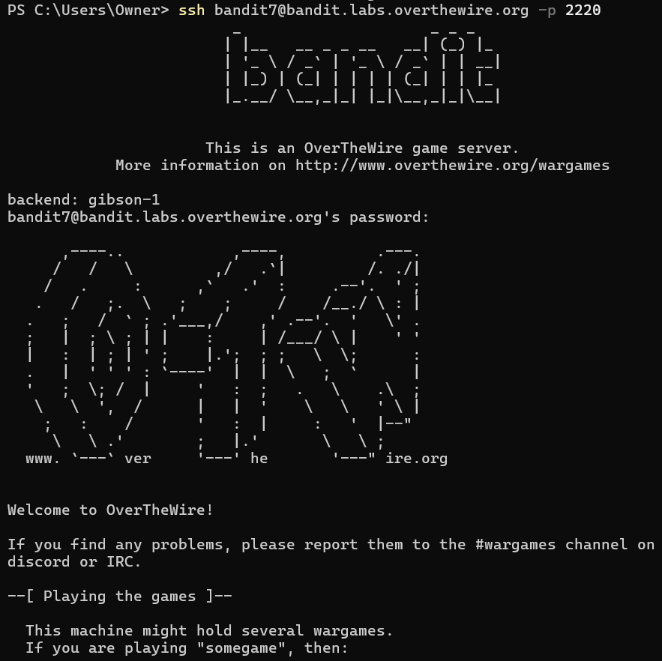
Used find to search for the password, since it said it could be anywhere in the server use '/' to start the search from the file system root, additionally used -size 33 to only look for files that are 33 bytes long, -user bandit7 to look for files belonging to user bandit7, -group bandit6 to look for files belonging to bandit6, and 2> /dev/null to tell Bash to discard errors, from this it gave me the file the password was stored in. Finally used cat to print out the password stored in the identified file.

Level 8:
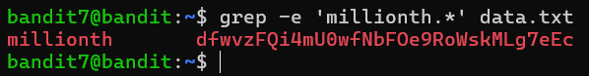
dfwvzFQi4mU0wfNbFOe9RoWskMLg7eEc
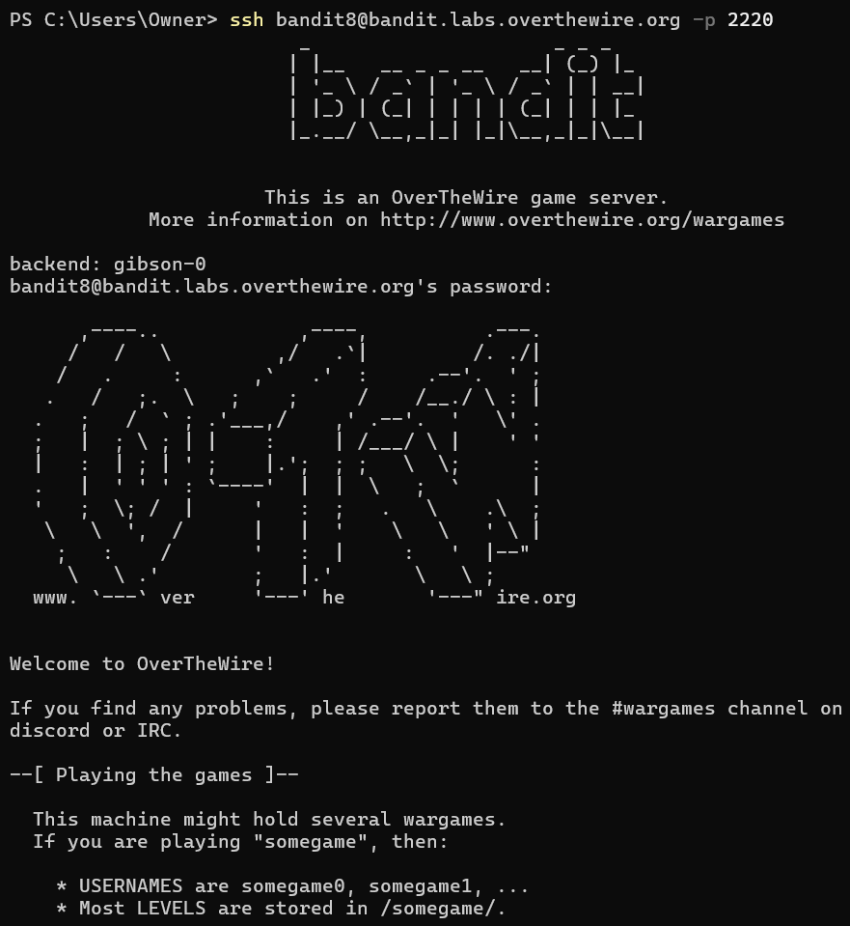
Used the grep command to search the data.txt file since it searches files for lines that matches specific patterns, -e was a flag that specifies the next argument is a pattern to search for, 'millionth.*' is enclosed in single quotes to prevent the shell from misinterpreting the special characters, without quotes the shell will think . is part of the search pattern, single quotes says to pass it exactly as it is to the grep command, ".*" just means to match any character any number of times. And data.txt is the file that grep is looking through.

Level 9:
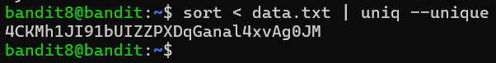
4CKMh1JI91bUIZZPXDqGanal4xvAg0JM
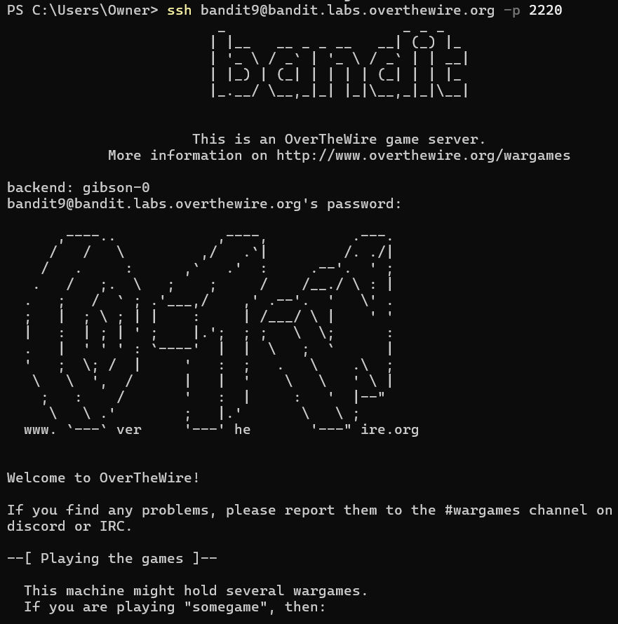
Used the sort command as it reads lines of a file and puts them in alphabetical or numerical order, the "<" is a redirection operator that tells the shell to take the contents of the next listed file (data.txt) and feed it into the sort command, "|" is the glue of the Linux command line where it takes the output of the command sort and sends it as an input of the next command, without the pipe, the output would need to be saved as a file. "uniq" is a command that filters out repeated lines, which is used because the password is the only line that happens once this is placed after the sort command because it only works on sorted data as it comapares a line to the one immediately following it, the –unique flag changes the behavior of the command to only print lines that were not repeated at all in the original source.

Level 10:
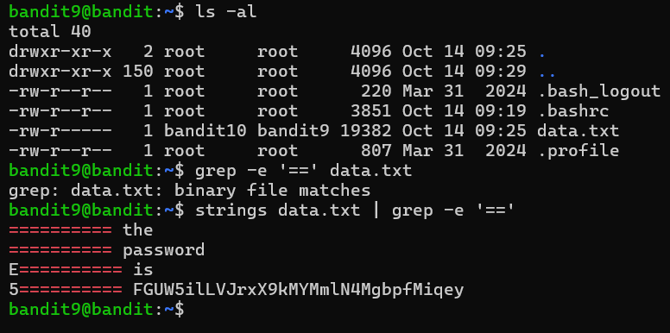
FGUW5ilLVJrxX9kMYMmlN4MgbpfMiqey
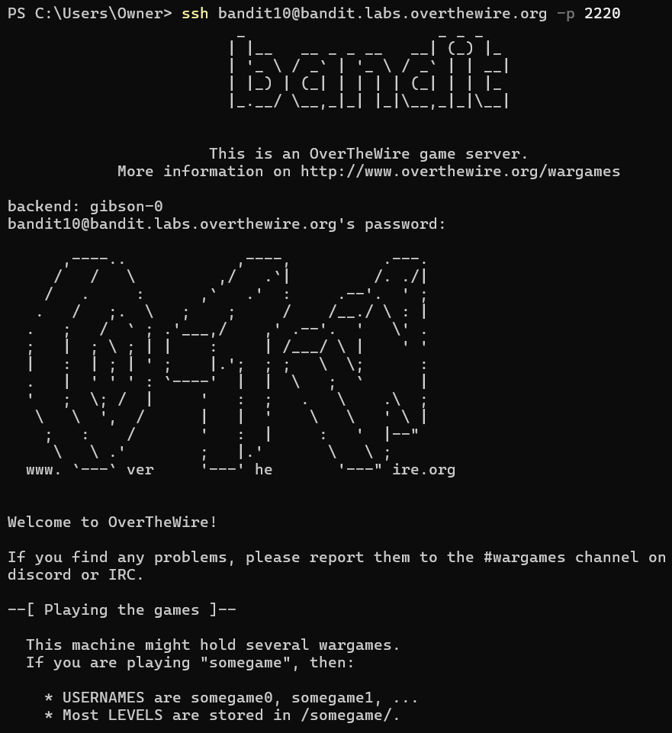
Used the string command because it said that the password was in one of the few human readable strings in the data.txt file, so string only pulls out the human readable text, data.txt is the target file that is being scanned, "|" is the pipe that takes the output of the previous command and uses it as the input to the next command to avoid having to create a new file, grep is the next command that is used that searches through the human readable lines in data.txt, -e tells the flag that the following string is a pattern, and '==' is the search pattern since the password is supposed to be preceded by several '=' characters, single quotes are used so the shell does not interpret the equals sign as a mathematical or assignment operator as it would with no quotes, and instead as a character.
Level 11:
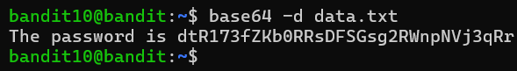
dtR173fZKb0RRsDFSGsg2RWnpNVj3qRr
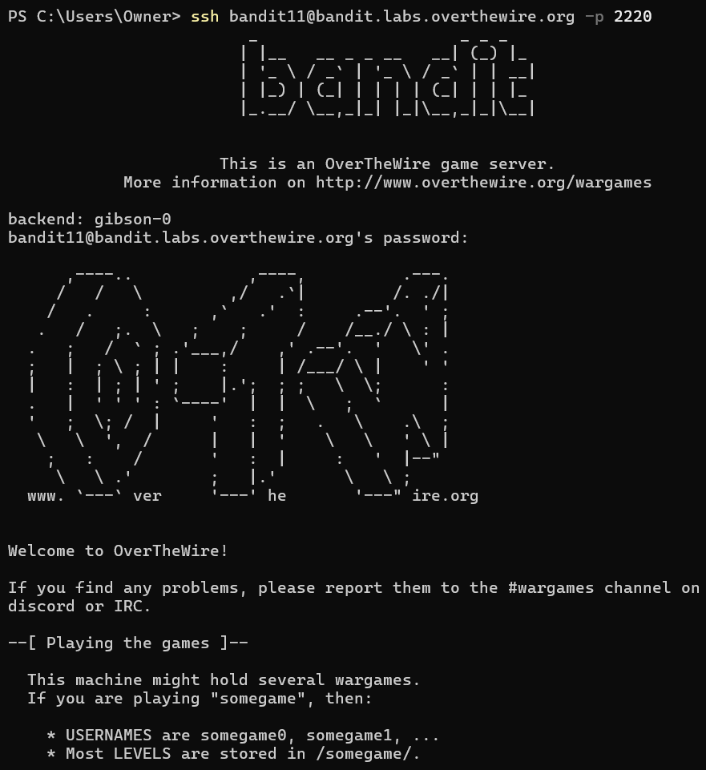
Used base64 command to translate the data back into human-readable text since the file the password is in has bas64 encoded data, -d is a flag that stands for decode since we want the information in the file to go from base64 encoded data to human readable data, and finally data.txt is the target file where the encoded password is stored.

